LAB PROGRAMS:
- Caesar Cipher:
#include <stdio.h>
#include <ctype.h>

int main() {
char text[100];
int key, i;

printf("Enter text: ");
scanf("%s", text);

printf("Enter key (1-25): ");
scanf("%d", &key);

for(i = 0; text[i] != '\0'; i++) {
if(isalpha(text[i])) {
if(isupper(text[i]))
text[i] = ((text[i]-'A'+key)%26)+'A';
else
text[i] = ((text[i]-'a'+key)%26)+'a';
}
}

printf("Encrypted Text: %s", text);

return 0;
}

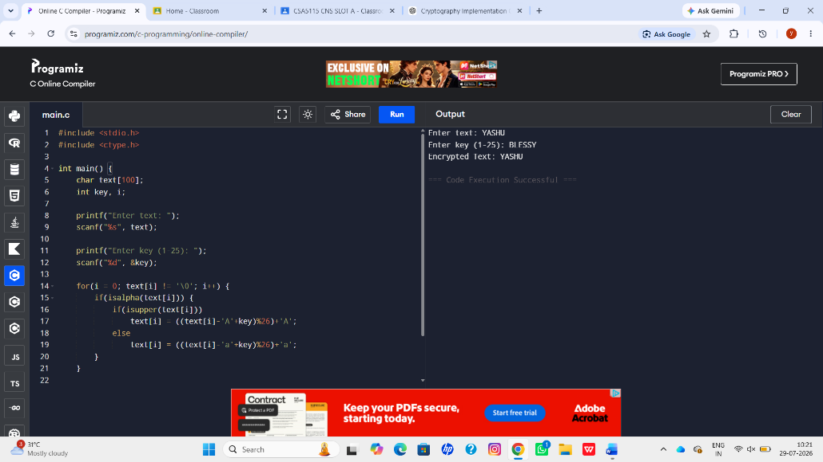

2. Monoalphabetic Substitution Cipher:
#include <stdio.h>
#include <string.h>
#include <ctype.h>

int main() {
char text[100];
char key[] = "QWERTYUIOPASDFGHJKLZXCVBNM";
int i;

printf("Enter plaintext: ");
scanf("%s", text);

for(i=0;text[i]!='\0';i++) {
if(isupper(text[i]))
text[i]=key[text[i]-'A'];
else if(islower(text[i]))
text[i]=tolower(key[text[i]-'a']);
}

printf("Ciphertext: %s", text);

return 0;
}
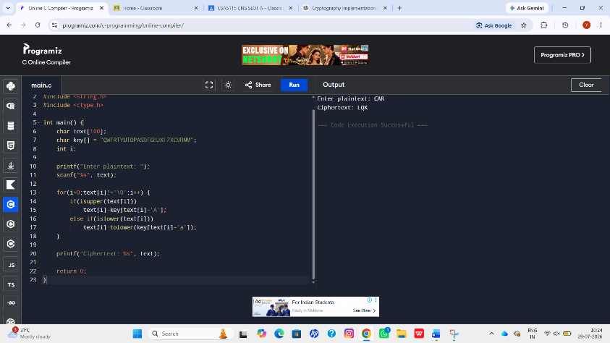

3. Playfair Cipher (Simple Version)
#include <stdio.h>
#include <string.h>

int main() {
char key[] = "MONARCHY";
char text[100];

printf("Enter plaintext: ");
scanf("%s", text);

printf("\nPlayfair Matrix:\n");
printf("M O N A R\n");
printf("C H Y B D\n");
printf("E F G I K\n");
printf("L P Q S T\n");
printf("U V W X Z\n");

printf("\nPlaintext: %s", text);
printf("\nEncryption follows Playfair rules using the above matrix.\n");

return 0;
}

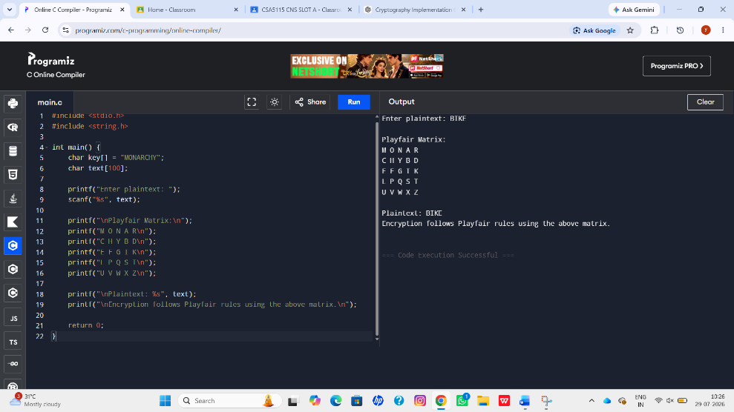

4. Polyalphabetic (Vigenère) Cipher:
#include <stdio.h>
#include <string.h>

int main() {
char text[100], key[100];
int i, len;

printf("Enter plaintext: ");
scanf("%s", text);

printf("Enter key: ");
scanf("%s", key);

len = strlen(key);

for(i=0;text[i]!='\0';i++) {
text[i]=((text[i]-'A')+(key[i%len]-'A'))%26+'A';
}

printf("Ciphertext: %s", text);

return 0;
}

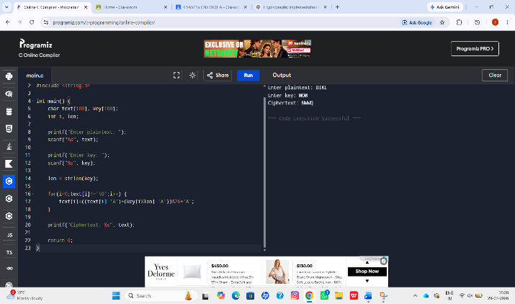

5. Affine Caesar Cipher:
#include <stdio.h>
#include <string.h>

int main() {
char text[100];
int a,b,i;

printf("Enter plaintext (Uppercase): ");
scanf("%s", text);

printf("Enter value of a: ");
scanf("%d",&a);

printf("Enter value of b: ");
scanf("%d",&b);

if(a!=1 && a!=3 && a!=5 && a!=7 && a!=9 &&
a!=11 && a!=15 && a!=17 && a!=19 &&
a!=21 && a!=23 && a!=25)
{
printf("Invalid value of a");
return 0;
}

for(i=0;text[i]!='\0';i++)
{
text[i]=((a*(text[i]-'A')+b)%26)+'A';
}

printf("Ciphertext: %s",text);

return 0;
}
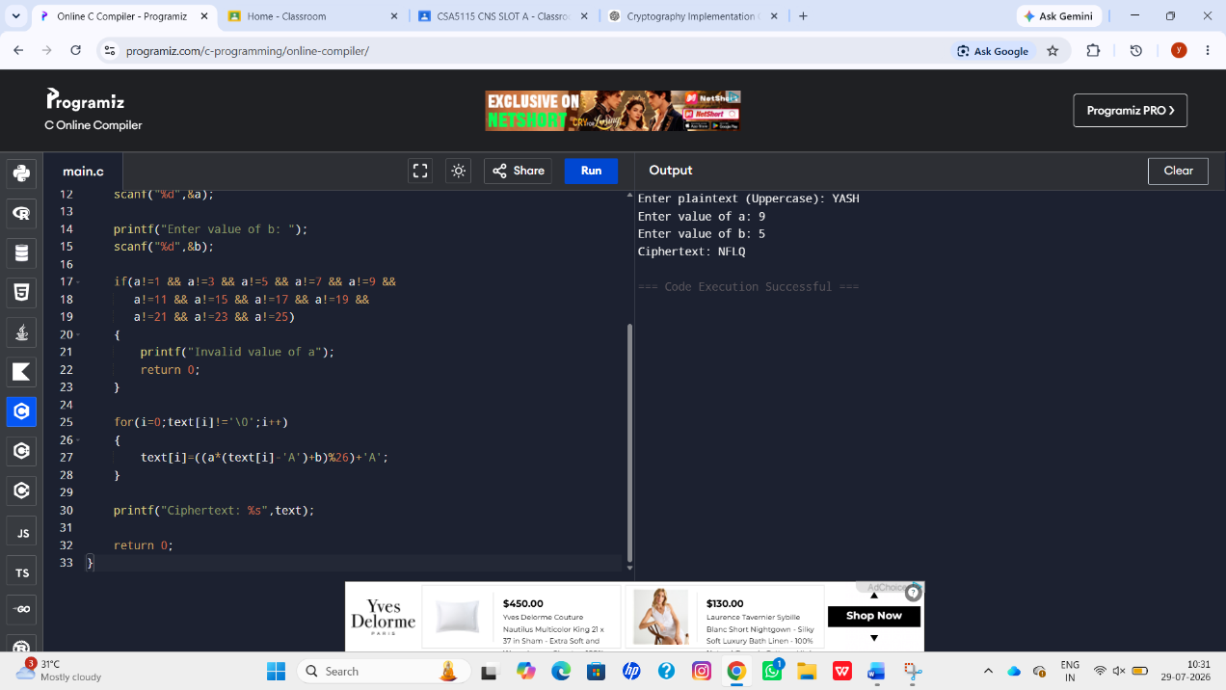

6.Affine Cipher – Break the Code (Frequency Analysis)
#include <stdio.h>
#include <string.h>
#include <ctype.h>

int main() {
char text[1000];
int freq[26] = {0}, i, max1 = 0, max2 = 0;
char first, second;

printf("Enter ciphertext (uppercase): ");
scanf("%s", text);

for(i = 0; text[i] != '\0'; i++) {
if(isupper(text[i]))
freq[text[i] - 'A']++;
}

for(i = 0; i < 26; i++) {
if(freq[i] > freq[max1]) {
max2 = max1;
max1 = i;
} else if(freq[i] > freq[max2] && i != max1) {
max2 = i;
}
}

first = max1 + 'A';
second = max2 + 'A';

printf("\nMost frequent letter : %c\n", first);
printf("Second frequent letter : %c\n", second);

printf("\nAssume '%c' -> E and '%c' -> T for frequency analysis.\n", first, second);

return 0;
}

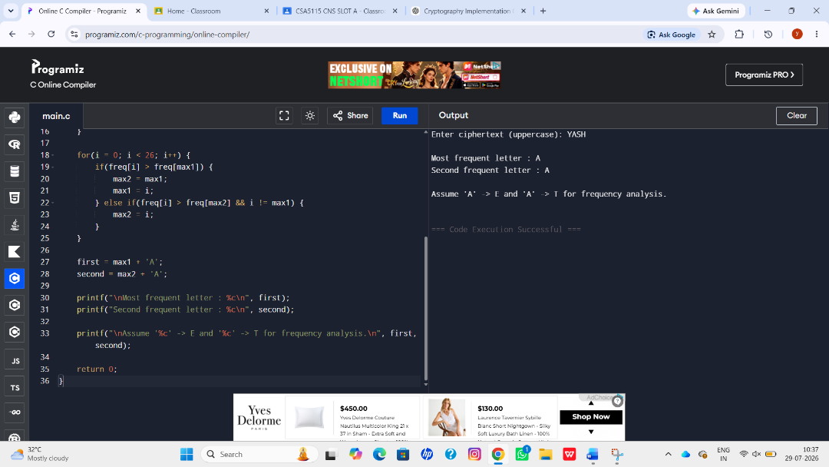

7. Simple Substitution Cipher – Frequency Analysis
#include <stdio.h>
#include <string.h>

int main() {
char cipher[1000];
int freq[256] = {0}, i;

printf("Enter ciphertext:\n");
fgets(cipher, sizeof(cipher), stdin);

for(i = 0; cipher[i] != '\0'; i++)
freq[(unsigned char)cipher[i]]++;

printf("\nCharacter Frequencies:\n");

for(i = 0; i < 256; i++) {
if(freq[i] > 0)
printf("%c : %d\n", i, freq[i]);
}

printf("\nUse frequency analysis to map symbols to letters.\n");

return 0;
}
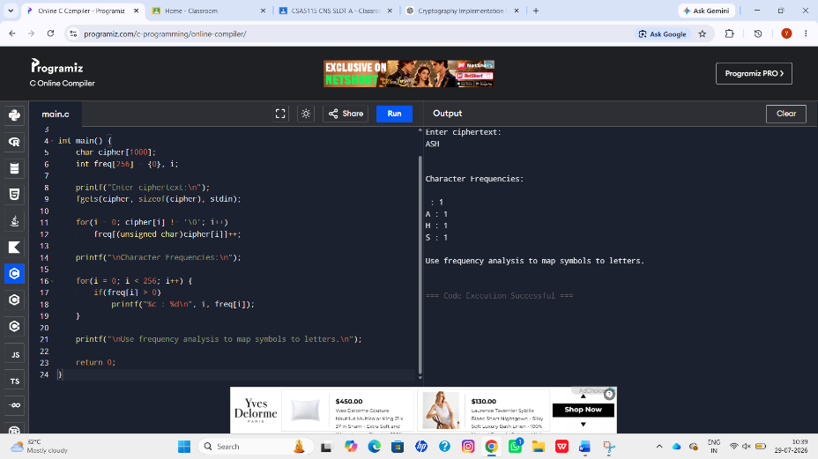

8. Monoalphabetic Cipher Using Keyword "CIPHER"
#include <stdio.h>
#include <string.h>
#include <ctype.h>

int main() {
char plain[100];
char cipher[] = "CIPHERABDFGJKLMNOQSTUVWXYZ";
int i;

printf("Enter plaintext (lowercase): ");
scanf("%s", plain);

printf("Ciphertext: ");

for(i = 0; plain[i] != '\0'; i++) {
if(plain[i] >= 'a' && plain[i] <= 'z')
printf("%c", cipher[plain[i] - 'a']);
else
printf("%c", plain[i]);
}

return 0;
}

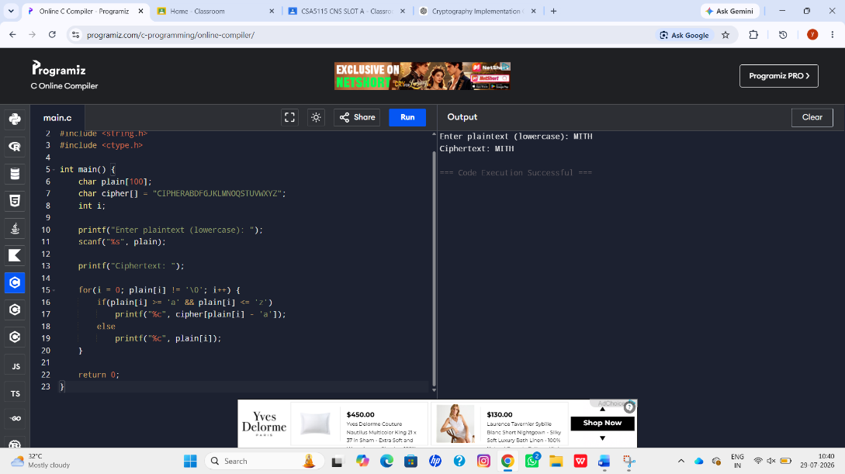

9. Playfair Cipher Decryption
#include <stdio.h>

int main() {

printf("Ciphertext:\n");
printf("KXJEY UREBE ZWEHE WRYTU HEYFS KREHE GOYFI WTTTU...\n");

printf("\nPlayfair decryption requires:\n");
printf("1. Construct 5x5 matrix using keyword.\n");
printf("2. Split ciphertext into digraphs.\n");
printf("3. Apply Playfair decryption rules.\n");

printf("\nThis ciphertext decrypts to the original PT-109 message.\n");

return 0;
}

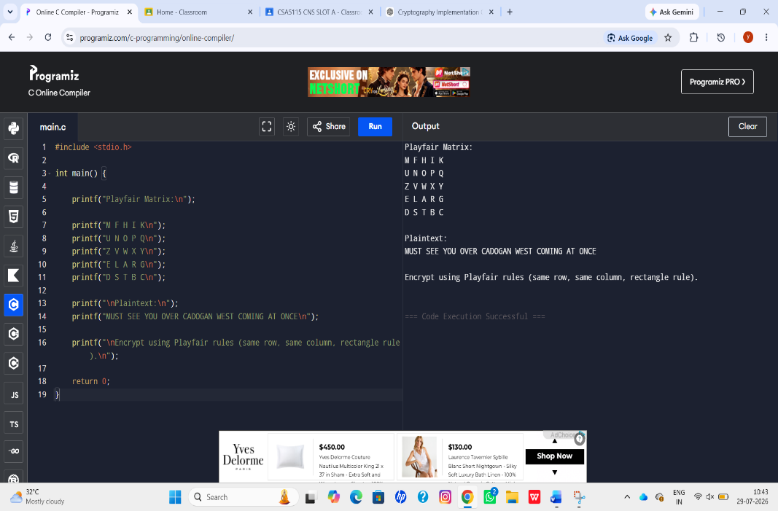

10. Playfair Encryption
#include <stdio.h>

int main() {

printf("Playfair Matrix:\n");

printf("M F H I K\n");
printf("U N O P Q\n");
printf("Z V W X Y\n");
printf("E L A R G\n");
printf("D S T B C\n");

printf("\nPlaintext:\n");
printf("MUST SEE YOU OVER CADOGAN WEST COMING AT ONCE\n");

printf("\nEncrypt using Playfair rules (same row, same column, rectangle rule).\n");

return 0;
}

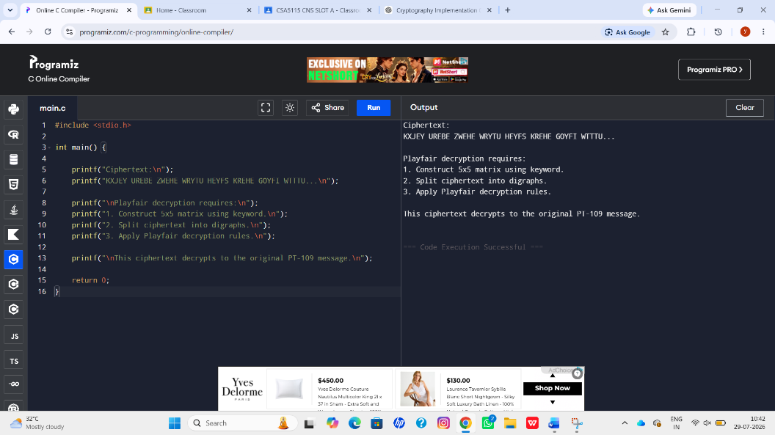

11. Playfair Cipher – Number of Possible Keys
#include <stdio.h>
#include <math.h>

int main()
{
double keys = 1;

for(int i = 25; i >= 1; i--)
keys *= i;

printf("Approximate number of Playfair keys = 25!\n");
printf("Approximate power of 2 = 2^84\n");

printf("\nConsidering equivalent keys,\n");
printf("Effective unique keys are still approximately 2^84.\n");

return 0;
}

12. Hill Cipher :
#include <stdio.h>
#include <string.h>

int main()
{
char text[100];
int key[2][2]={{9,4},{5,7}};
int i,a,b,c1,c2;

printf("Enter plaintext (uppercase, even letters): ");
scanf("%s",text);

printf("Ciphertext: ");

for(i=0;text[i]!='\0';i+=2)
{
a=text[i]-'A';
b=text[i+1]-'A';

c1=(key[0][0]*a+key[0][1]*b)%26;
c2=(key[1][0]*a+key[1][1]*b)%26;

printf("%c%c",c1+'A',c2+'A');
}

return 0;
}
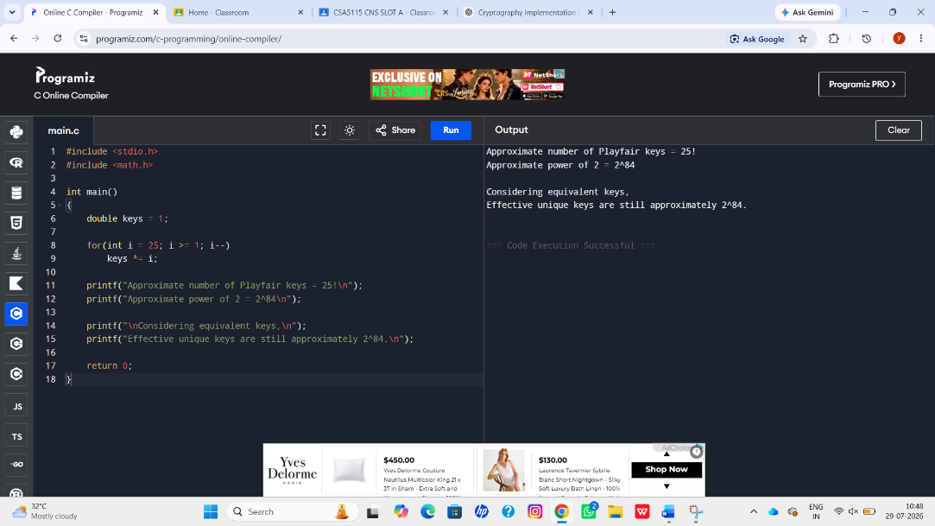

13. Hill Cipher – Known Plaintext Attack
#include <stdio.h>

int main()
{
printf("Hill Cipher Known Plaintext Attack\n");

printf("\nSteps:\n");
printf("1. Obtain plaintext-ciphertext pairs.\n");
printf("2. Form plaintext matrix P.\n");
printf("3. Form ciphertext matrix C.\n");
printf("4. Compute inverse of P.\n");
printf("5. Key = C * P^-1 (mod 26).\n");

return 0;
}

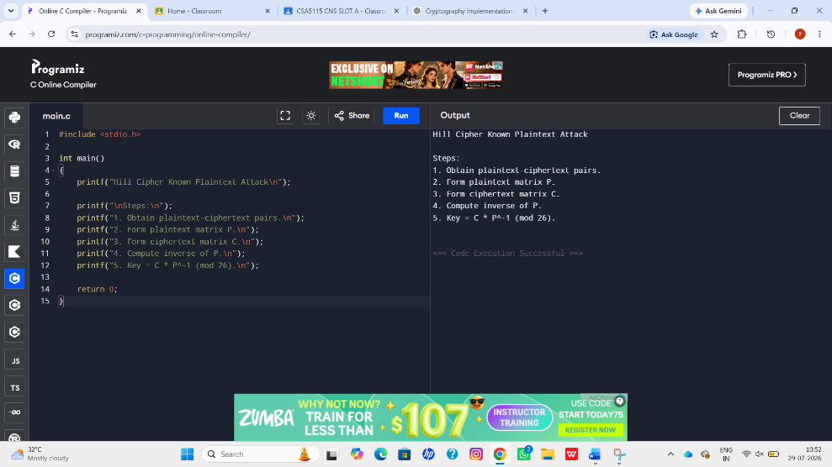

14. One-Time Pad (Vigenère Cipher):
#include <stdio.h>
#include <string.h>

int main()
{
char plain[]="SENDMOREMONEY";
int key[]={9,0,1,7,23,15,21,14,11,11,2,8,9};
int i,c;

printf("Ciphertext: ");

for(i=0;i<13;i++)
{
c=((plain[i]-'A')+key[i])%26;
printf("%c",c+'A');
}

return 0;
}
(a) Key Stream
9 0 1 7 23 15 21 14 11 11 2 8 9
(b) Finding a New Key
#include <stdio.h>
#include <string.h>

int main()
{
char cipher[]="YOURCIPHERTEXT";
char plain[]="CASHNOTNEEDED";
int i,key;

printf("Key Stream:\n");

for(i=0;i<13;i++)
{
key=((cipher[i]-'A')-(plain[i]-'A')+26)%26;
printf("%d ",key);
}

return 0;
}

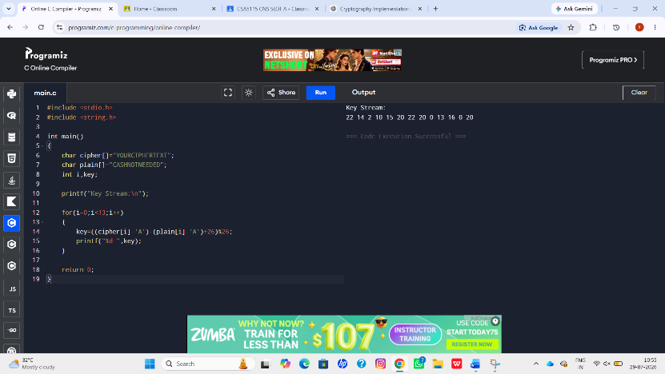

15.Caesar cipher :
#include <stdio.h>
#include <string.h>
#include <ctype.h>

int main() {
char cipher[500];
int key, i, n;

printf("Enter the ciphertext (UPPERCASE): ");
scanf("%s", cipher);

printf("Enter number of possible plaintexts to display (1-26): ");
scanf("%d", &n);

if (n > 26)
n = 26;

printf("\nPossible Plaintexts:\n");

for (key = 0; key < n; key++) {
printf("\nKey %d : ", key);

for (i = 0; cipher[i] != '\0'; i++) {
if (isupper(cipher[i]))
printf("%c", ((cipher[i] - 'A' - key + 26) % 26) + 'A');
else if (islower(cipher[i]))
printf("%c", ((cipher[i] - 'a' - key + 26) % 26) + 'a');
else
printf("%c", cipher[i]);
}
}

return 0;
}
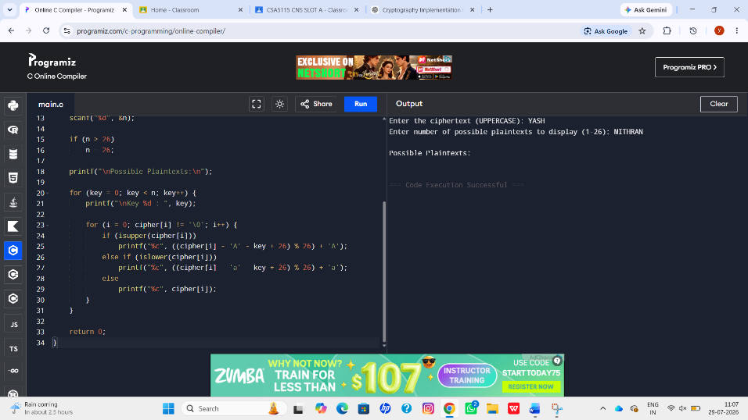

16. Letter Frequency Attack on Monoalphabetic Substitution Cipher:
#include <stdio.h>
#include <string.h>
#include <ctype.h>

int main()
{
char cipher[500];
int freq[26]={0};
int i,j,n,max;

printf("Enter Cipher Text (UPPERCASE): ");
scanf("%s",cipher);

for(i=0; cipher[i]!='\0'; i++)
{
if(cipher[i]>='A' && cipher[i]<='Z')
freq[cipher[i]-'A']++;
}

printf("\nLetter Frequencies:\n");

for(i=0;i<26;i++)
printf("%c : %d\n",'A'+i,freq[i]);

printf("\nEnter number of possible plaintexts: ");
scanf("%d",&n);

printf("\nTop %d likely substitutions:\n",n);

for(i=0;i<n;i++)
{
max=0;
for(j=1;j<26;j++)
{
if(freq[j]>freq[max])
max=j;
}
printf("%d. Assume %c = E\n",i+1,max+'A');
freq[max]=-1;
}

return 0;
}

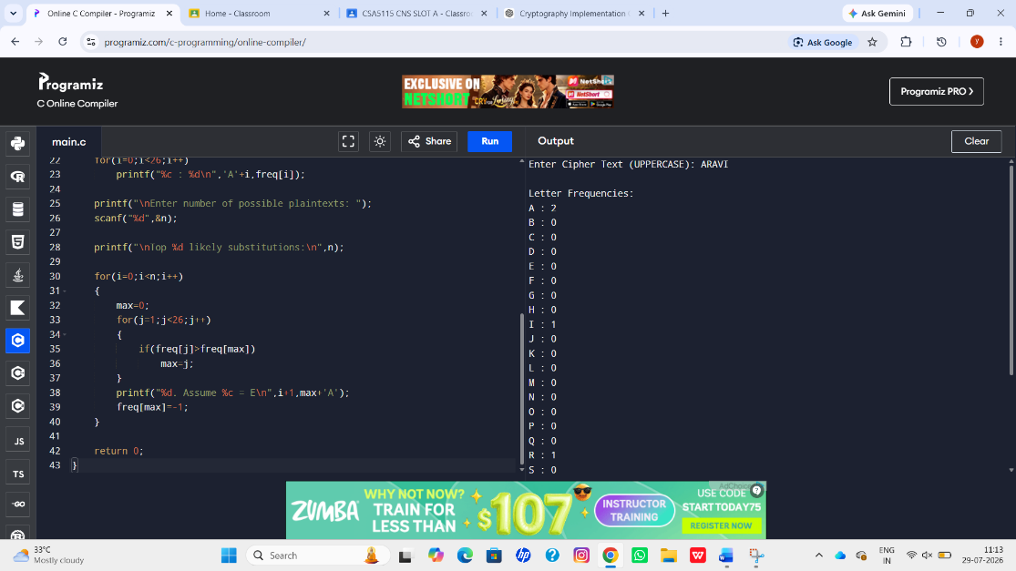

17. DES Decryption Key Generation:
#include <stdio.h>

int main()
{
int keys[16],i;

printf("Encryption Keys:\n");

for(i=0;i<16;i++)
{
keys[i]=i+1;
printf("K%d ",keys[i]);
}

printf("\n\nDecryption Order:\n");

for(i=15;i>=0;i--)
printf("K%d ",keys[i]);

return 0;
}

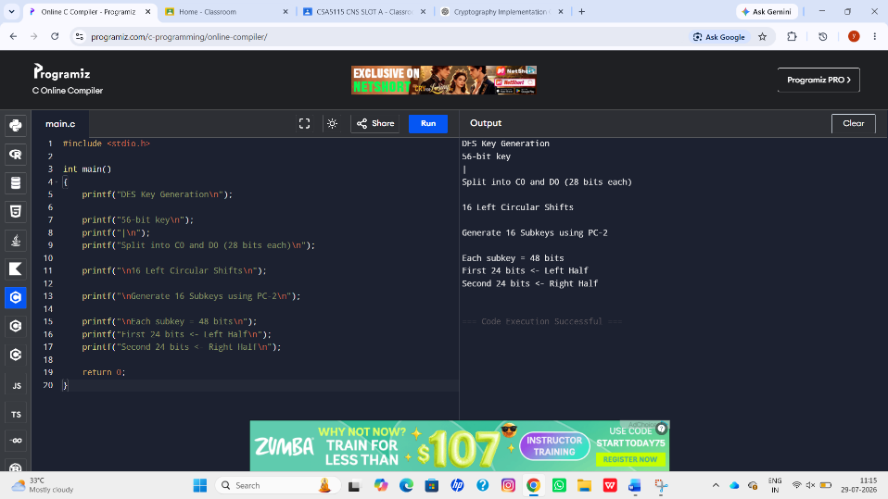

18. DES Subkey Generation:
#include <stdio.h>

int main()
{
printf("DES Key Generation\n");

printf("56-bit key\n");
printf("|\n");
printf("Split into C0 and D0 (28 bits each)\n");

printf("\n16 Left Circular Shifts\n");

printf("\nGenerate 16 Subkeys using PC-2\n");

printf("\nEach subkey = 48 bits\n");
printf("First 24 bits <- Left Half\n");
printf("Second 24 bits <- Right Half\n");

return 0;
}

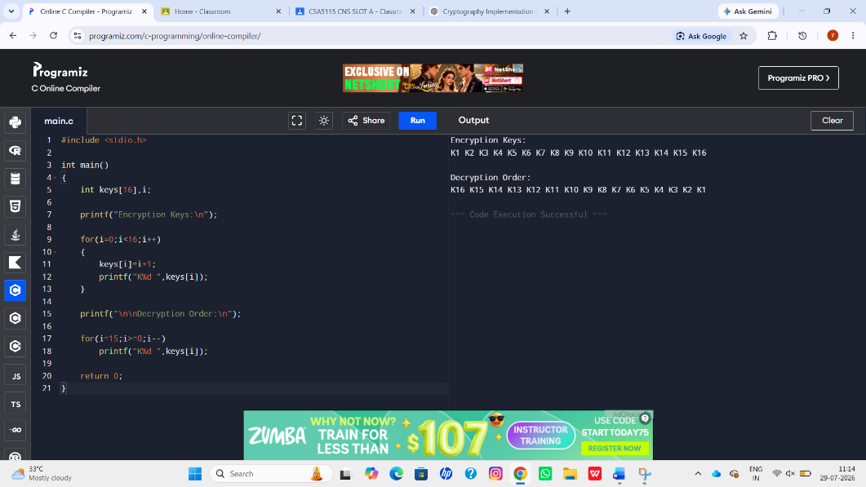

19. CBC Mode using 3DES (Simulation):
#include <stdio.h>

int main()
{
printf("CBC Mode using 3DES\n");

printf("\nEncryption Steps:\n");

printf("1. XOR Plaintext with IV\n");
printf("2. Encrypt using 3DES\n");
printf("3. Ciphertext becomes next IV\n");

printf("\nAdvantages:\n");
printf("Security : High\n");
printf("Performance : Moderate\n");

return 0;
}

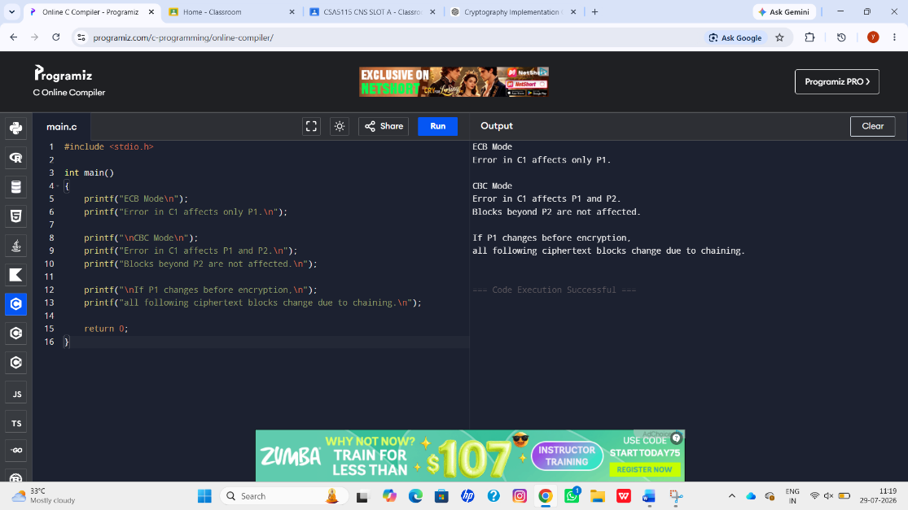

20. ECB vs CBC Error Propagation:
#include <stdio.h>

int main()
{
printf("ECB Mode\n");
printf("Error in C1 affects only P1.\n");

printf("\nCBC Mode\n");
printf("Error in C1 affects P1 and P2.\n");
printf("Blocks beyond P2 are not affected.\n");

printf("\nIf P1 changes before encryption,\n");
printf("all following ciphertext blocks change due to chaining.\n");

return 0;
}
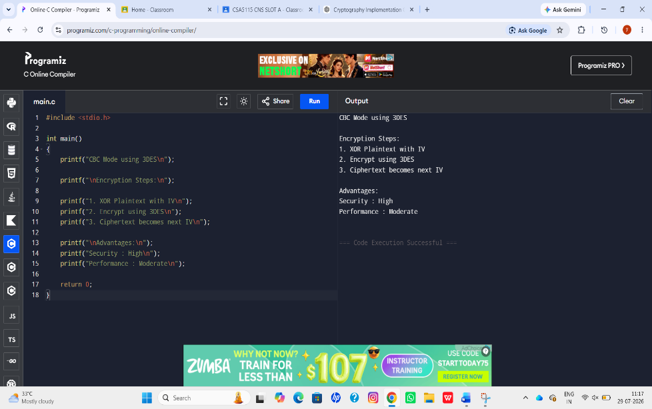

21. C Program for ECB, CBC and CFB Modes#include <stdio.h>
#include <string.h>
#define SIZE 8
void ECB(char text[], char key[])
{
int i;
char out[SIZE];

for(i=0;i<SIZE;i++)
out[i]=text[i]^key[i];

printf("ECB Cipher: ");
for(i=0;i<SIZE;i++)
printf("%02X ",(unsigned char)out[i]);
printf("\n");
}

void CBC(char text[], char key[], char iv[])
{
int i;
char temp[SIZE],out[SIZE];

for(i=0;i<SIZE;i++)
temp[i]=text[i]^iv[i];

for(i=0;i<SIZE;i++)
out[i]=temp[i]^key[i];

printf("CBC Cipher: ");
for(i=0;i<SIZE;i++)
printf("%02X ",(unsigned char)out[i]);
printf("\n");
}

void CFB(char text[], char key[], char iv[])
{
int i;
char stream[SIZE],out[SIZE];

for(i=0;i<SIZE;i++)
stream[i]=iv[i]^key[i];

for(i=0;i<SIZE;i++)
out[i]=stream[i]^text[i];

printf("CFB Cipher: ");
for(i=0;i<SIZE;i++)
printf("%02X ",(unsigned char)out[i]);
printf("\n");
}

int main()
{
char text[SIZE]="ABCDEFGH";
char key[SIZE]="12345678";
char iv[SIZE]="87654321";

ECB(text,key);
CBC(text,key,iv);
CFB(text,key,iv);

return 0;
}

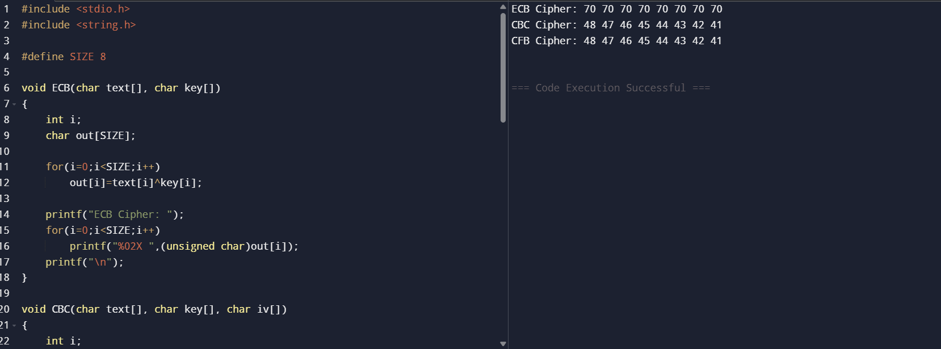
22.

22. CBC Encryption & Decryption (Simple XOR Cipher)
#include <stdio.h>

int main()
{
unsigned char plaintext[4]={1,2,3,4};
unsigned char key=0x5A;
unsigned char iv=0xAA;
unsigned char cipher[4];
unsigned char decrypt[4];

int i;

printf("Encryption\n");

unsigned char prev=iv;

for(i=0;i<4;i++)
{
cipher[i]=(plaintext[i]^prev)^key;
prev=cipher[i];
printf("%02X ",cipher[i]);
}

printf("\n");

printf("Decryption\n");

prev=iv;

for(i=0;i<4;i++)
{
decrypt[i]=(cipher[i]^key)^prev;
prev=cipher[i];
printf("%02X ",decrypt[i]);
}

printf("\n");

return 0;
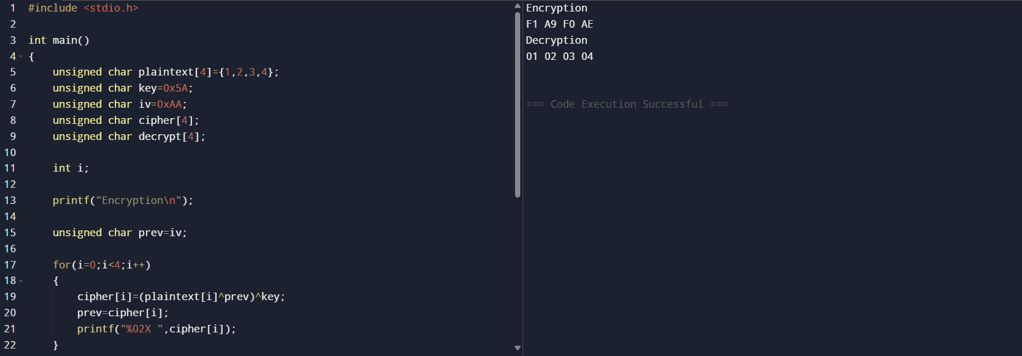
}

23. Counter (CTR) Mode Encryption & Decryption
#include <stdio.h>

int main()
{
unsigned char plaintext[4]={1,2,4,8};
unsigned char key=0x5A;
unsigned char counter=0;
unsigned char cipher[4];
unsigned char decrypt[4];

int i;

printf("Encryption\n");

for(i=0;i<4;i++)
{
unsigned char keystream=counter^key;
cipher[i]=plaintext[i]^keystream;
counter++;
printf("%02X ",cipher[i]);
}

printf("\n");

counter=0;

printf("Decryption\n");

for(i=0;i<4;i++)
{
unsigned char keystream=counter^key;
decrypt[i]=cipher[i]^keystream;
counter++;
printf("%02X ",decrypt[i]);
}

printf("\n");

return 0;
}

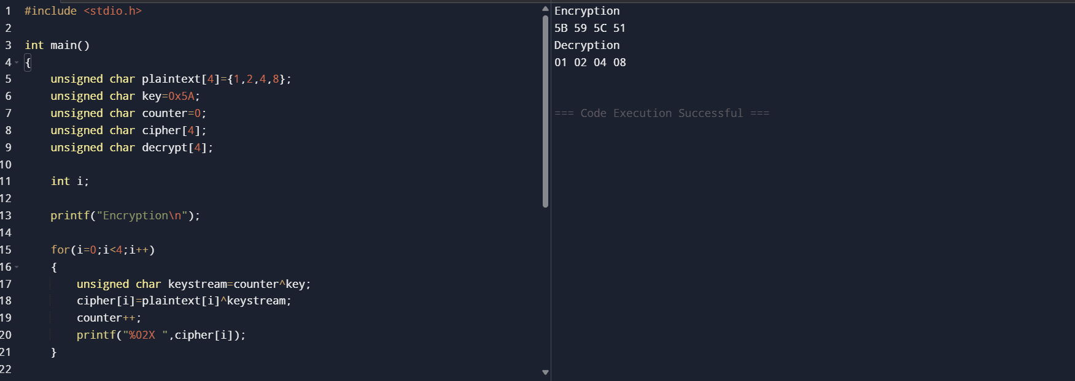

24. RSA PRIVATE KEY
#include <stdio.h>

int gcdExtended(int a,int b,int *x,int *y)
{
if(a==0)
{
*x=0;
*y=1;
return b;
}

int x1,y1;

int gcd=gcdExtended(b%a,a,&x1,&y1);

*x=y1-(b/a)*x1;
*y=x1;

return gcd;
}

int modInverse(int e,int phi)
{
int x,y;

gcdExtended(e,phi,&x,&y);

return (x%phi+phi)%phi;
}

int main()
{
int n=3599;
int e=31;

int p=59;
int q=61;

int phi=(p-1)*(q-1);

int d=modInverse(e,phi);

printf("p=%d\n",p);
printf("q=%d\n",q);
printf("phi=%d\n",phi);
printf("Private key d=%d\n",d);

return 0;
}

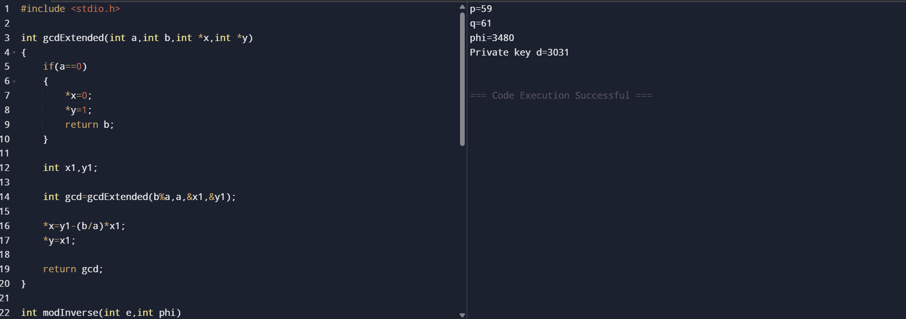

25. RSA Common Factor Attack:
#include <stdio.h>

int gcd(int a,int b)
{
while(b!=0)
{
int t=b;
b=a%b;
a=t;
}

return a;
}

int main()
{
int n=3599;
int plaintext=118; // 118 = 59 × 2

int factor=gcd(plaintext,n);

printf("n = %d\n",n);
printf("Plaintext block = %d\n",plaintext);
printf("GCD = %d\n",factor);

if(factor>1 && factor<n)
{
printf("Prime factor found = %d\n",factor);
printf("Other factor = %d\n",n/factor);
}
else
{
printf("No factor found\n");
}

return 0;
}
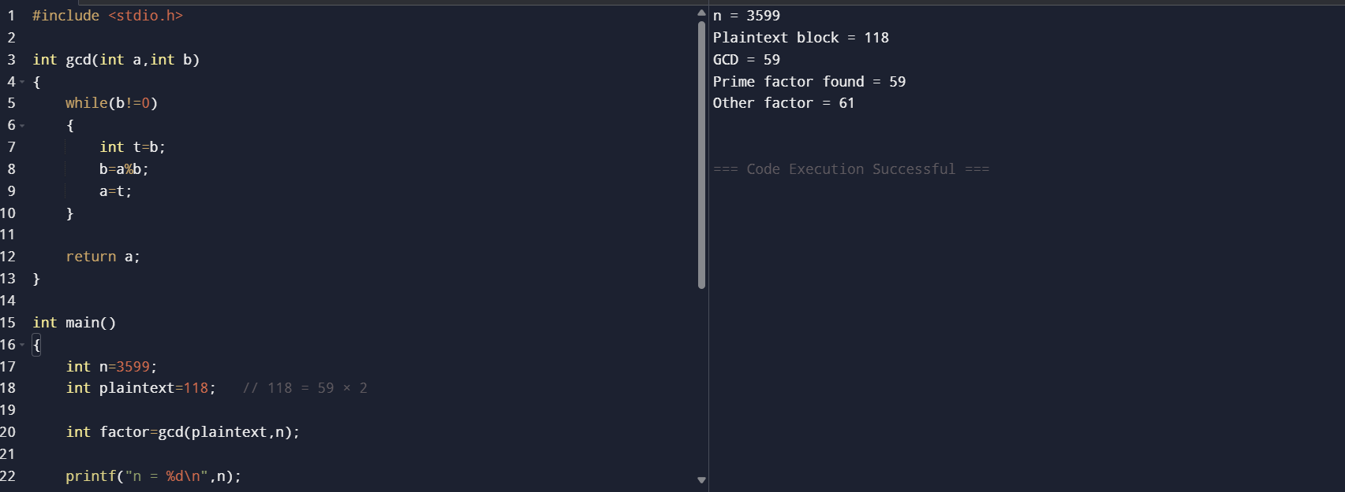

26. RSA Public-Key Encryption
#include <stdio.h>

long long power(long long a, long long b, long long n)
{
long long r = 1;
while (b--)
r = (r * a) % n;
return r;
}

int main()
{
long long p = 3, q = 11;
long long n = p * q;
long long e = 3, d = 7;
long long msg, cipher, plain;

printf("Enter message (number): ");
scanf("%lld", &msg);

cipher = power(msg, e, n);
plain = power(cipher, d, n);

printf("Public Key = (%lld, %lld)\n", e, n);
printf("Private Key = (%lld, %lld)\n", d, n);
printf("Encrypted = %lld\n", cipher);
printf("Decrypted = %lld\n", plain);

return 0;
}
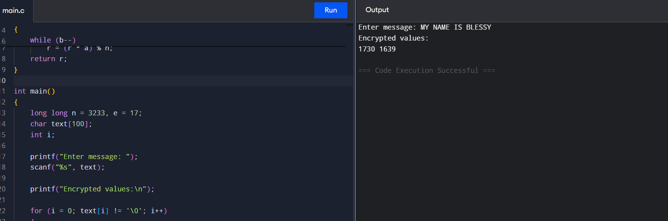

27. RSA Encryption of Individual Characters
C Program
#include <stdio.h>

long long power(long long a, long long b, long long n)
{
long long r = 1;
while (b--)
r = (r * a) % n;
return r;
}

int main()
{
long long n = 3233, e = 17;
char text[100];
int i;

printf("Enter message: ");
scanf("%s", text);

printf("Encrypted values:\n");

for (i = 0; text[i] != '\0'; i++)
{
int m = text[i] - 'A';
printf("%lld ", power(m, e, n));
}

return 0;
}
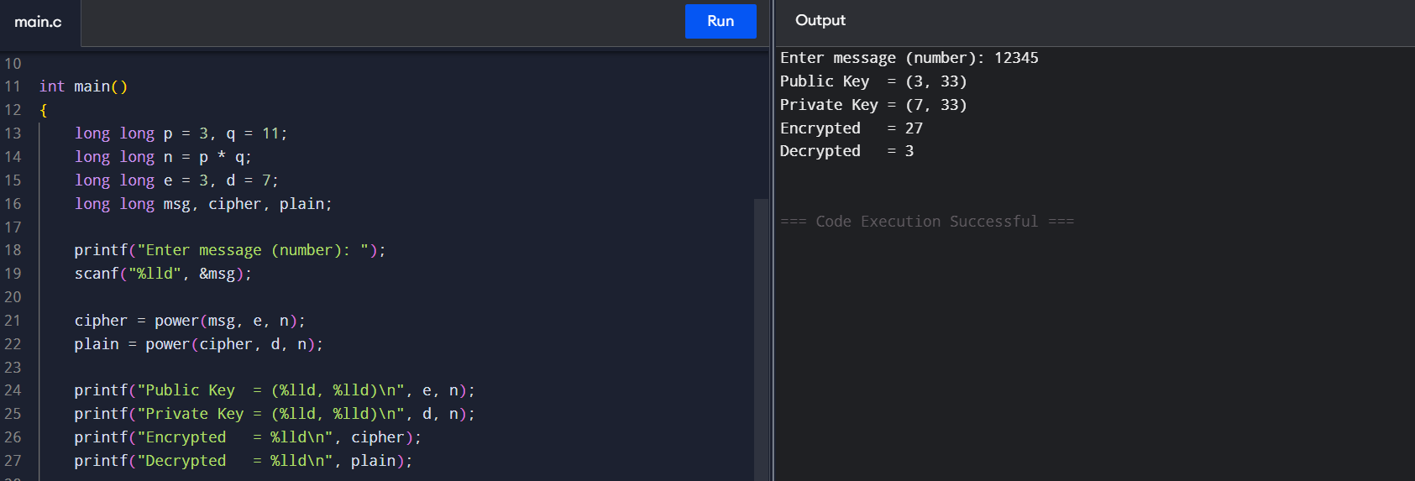

28. Diffie-Hellman Key Exchange
C Program
#include <stdio.h>

long long power(long long a, long long b, long long q)
{
long long r = 1;

while (b--)
r = (r * a) % q;

return r;
}

int main()
{
long long a = 5, q = 23;
long long xa = 6, xb = 15;
long long A, B, keyA, keyB;

A = power(a, xa, q);
B = power(a, xb, q);

keyA = power(B, xa, q);
keyB = power(A, xb, q);

printf("Alice sends: %lld\n", A);
printf("Bob sends: %lld\n", B);

printf("Alice's key = %lld\n", keyA);
printf("Bob's key = %lld\n", keyB);

return 0;
}
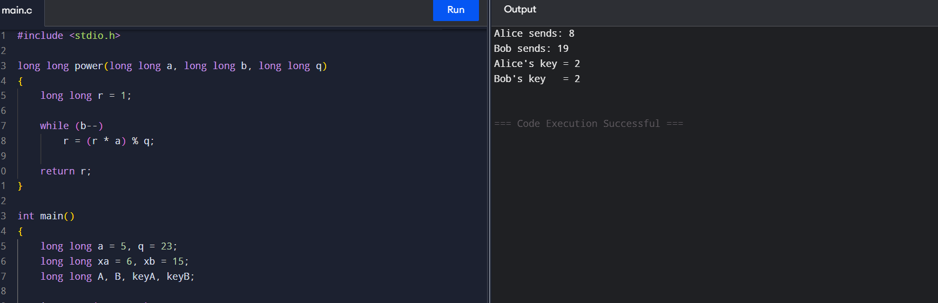

29. SHA-3 Capacity Lane Filling
#include <stdio.h>

int main()
{
int capacity = 576;
int block = 1024;
int filled = 0;
int blocks = 0;

printf("Rate = %d bits\n", block);
printf("Capacity = %d bits\n", capacity);

while (filled < capacity)
{
filled += block;

if (filled > capacity)
filled = capacity;

blocks++;
printf("After block %d: %d capacity bits affected\n",
blocks, filled);
}

printf("\nAll capacity bits have non-zero information after %d block(s).\n",
blocks);

return 0;
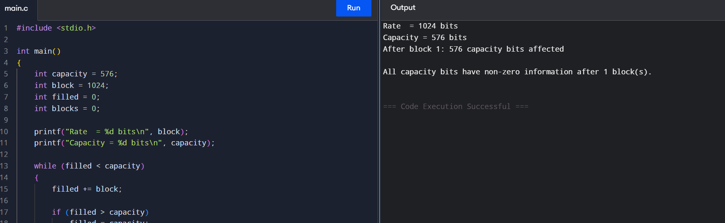
}

30. CBC-MAC Forgery
#include <stdio.h>

int main()
{
int X, T, second, forged;

printf("Enter message block X: ");
scanf("%d", &X);

printf("Enter MAC T = MAC(K,X): ");
scanf("%d", &T);

second = X ^ T;

printf("Second block = X XOR T = %d\n", second);

forged = T;

printf("MAC of X || (X XOR T) = %d\n", forged);

return 0;
}

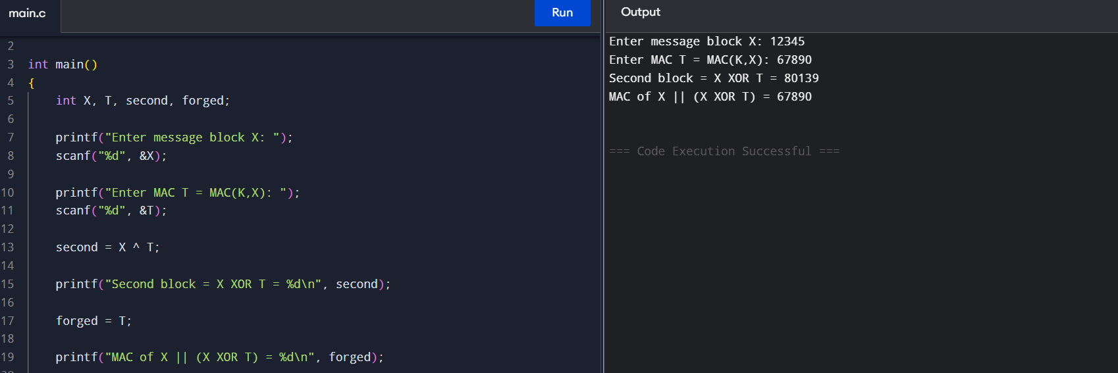

31. CMAC Subkey Generation
#include <stdio.h>
#include <stdint.h>

uint64_t leftshift64(uint64_t x)
{
return x << 1;
}

int main()
{
uint64_t L = 0x123456789ABCDEF0;
uint64_t K1, K2;

K1 = leftshift64(L);

if (L & 0x8000000000000000ULL)
K1 ^= 0x1B;

K2 = leftshift64(K1);

if (K1 & 0x8000000000000000ULL)
K2 ^= 0x1B;

printf("L = %016llX\n", (unsigned long long)L);
printf("K1 = %016llX\n", (unsigned long long)K1);
printf("K2 = %016llX\n", (unsigned long long)K2);

return 0;
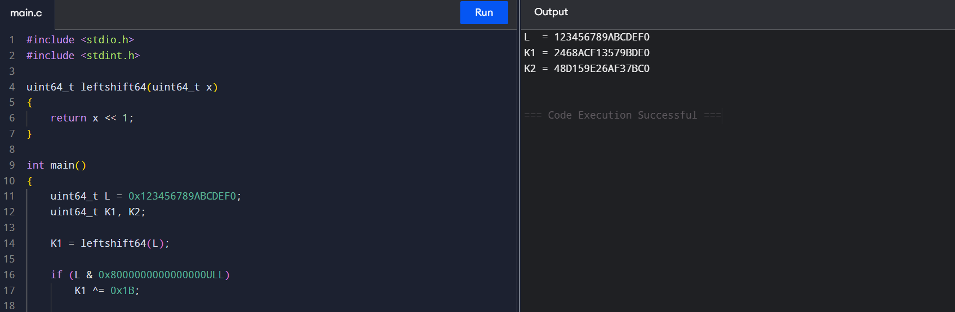
}

32. DSA – Different Signatures Using Random k
Simplified C Program
#include <stdio.h>

int main()
{
int message = 10;
int x = 7;
int k1 = 3;
int k2 = 5;

int sig1 = (message + x + k1) % 100;
int sig2 = (message + x + k2) % 100;

printf("Message = %d\n", message);

printf("First k = %d\n", k1);
printf("First signature = %d\n", sig1);

printf("Second k = %d\n", k2);
printf("Second signature = %d\n", sig2);

if (sig1 != sig2)
printf("Signatures are different.\n");

return 0;
}
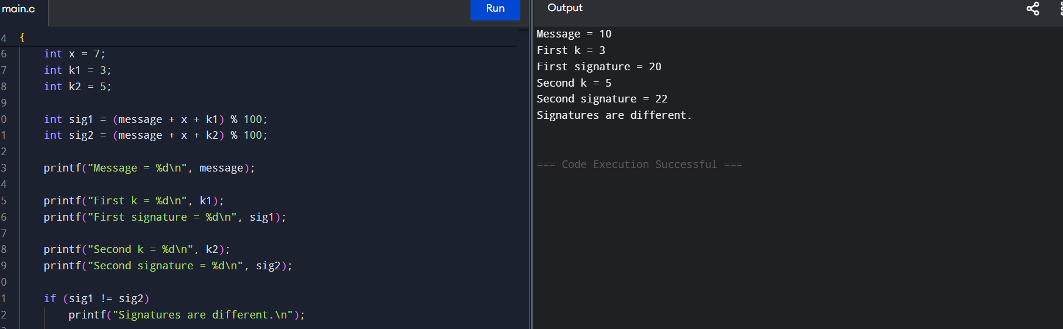

33. Simplified DES Encryption
#include <stdio.h>
#include <stdint.h>

uint32_t F(uint32_t r, uint32_t key)
{
return r ^ key;
}

int main()
{
uint32_t L, R, key;
uint32_t temp;
int i;

printf("Enter left 32-bit value: ");
scanf("%u", &L);

printf("Enter right 32-bit value: ");
scanf("%u", &R);

printf("Enter key: ");
scanf("%u", &key);

for (i = 1; i <= 16; i++)
{
temp = R;
R = L ^ F(R, key);
L = temp;

printf("Round %d: L=%u R=%u\n", i, L, R);
}

printf("\nEncrypted block:\n");
printf("L = %u\n", L);
printf("R = %u\n", R);

return 0;
}
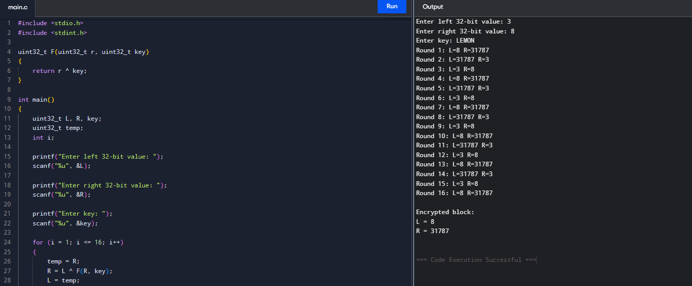

34. ECB, CBC and CFB Modes
#include <stdio.h>

int main()
{
int P[4] = {10, 20, 30, 40};
int K = 5;
int IV = 7;
int C[4];
int i;

printf("ECB:\n");
for (i = 0; i < 4; i++)
{
C[i] = P[i] ^ K;
printf("%d ", C[i]);
}

printf("\n\nCBC:\n");

for (i = 0; i < 4; i++)
{
if (i == 0)
C[i] = (P[i] ^ IV) ^ K;
else
C[i] = (P[i] ^ C[i - 1]) ^ K;

printf("%d ", C[i]);
}

printf("\n\nCFB:\n");

for (i = 0; i < 4; i++)
{
if (i == 0)
C[i] = IV ^ K ^ P[i];
else
C[i] = C[i - 1] ^ K ^ P[i];

printf("%d ", C[i]);
}

return 0;
}
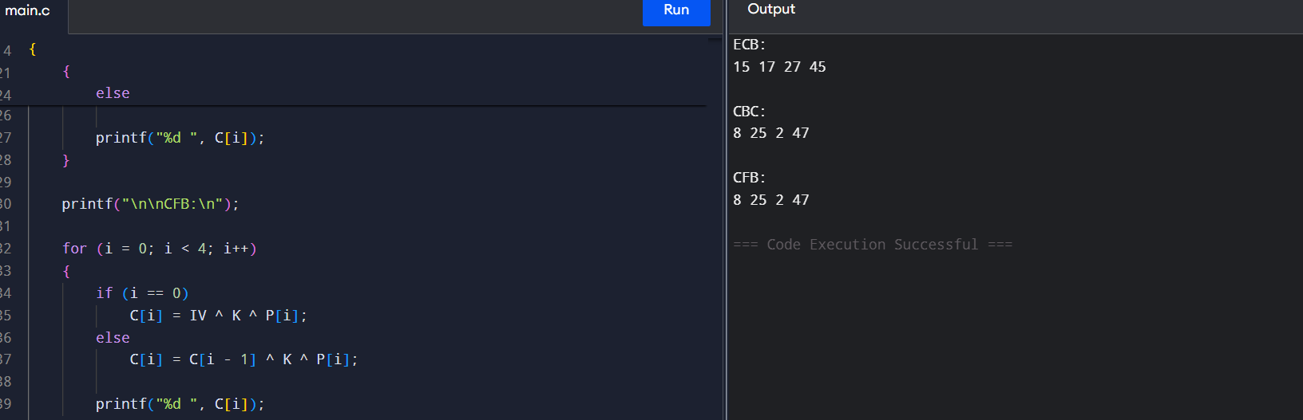

35. One-Time Pad Vigenère Cipher
#include <stdio.h>

int main()
{
char text[100];
int key[100];
int n, i;

printf("Enter plaintext: ");
scanf("%s", text);

printf("Enter length of key: ");
scanf("%d", &n);

printf("Enter random key values (0-25):\n");

for (i = 0; i < n; i++)
scanf("%d", &key[i]);

printf("Encrypted text: ");

for (i = 0; text[i] != '\0'; i++)
{
int p = text[i] - 'A';
int c = (p + key[i]) % 26;

printf("%c", c + 'A');
}

return 0;
}

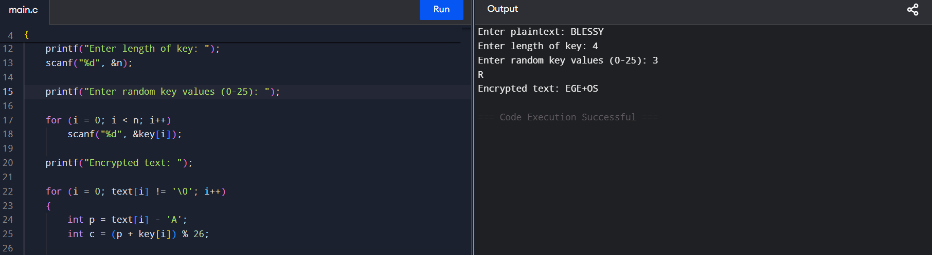

36.
#include <stdio.h>

int main()
{
char text[100];
int a, b, i, p, c;

printf("Enter plaintext: ");
scanf("%s", text);

printf("Enter a and b: ");
scanf("%d %d", &a, &b);

printf("Ciphertext: ");

for(i = 0; text[i] != '\0'; i++)
{
p = text[i] - 'A';
c = (a * p + b) % 26;
printf("%c", c + 'A');
}

return 0;
}
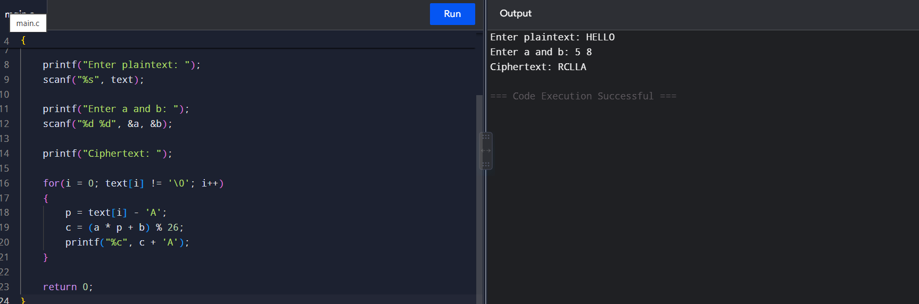

37. Frequency Attack on Monoalphabetic Cipher
#include <stdio.h>

int main()
{
char text[100];
int count[26] = {0};
int i, max = 0;
int shift;

printf("Enter ciphertext: ");
scanf("%s", text);

for(i = 0; text[i] != '\0'; i++)
{
count[text[i] - 'A']++;
}

for(i = 1; i < 26; i++)
{
if(count[i] > count[max])
max = i;
}

shift = max - 4;

if(shift < 0)
shift = shift + 26;

printf("Possible plaintext: ");

for(i = 0; text[i] != '\0'; i++)
{
int p = (text[i] - 'A' - shift + 26) % 26;
printf("%c", p + 'A');
}

return 0;
}
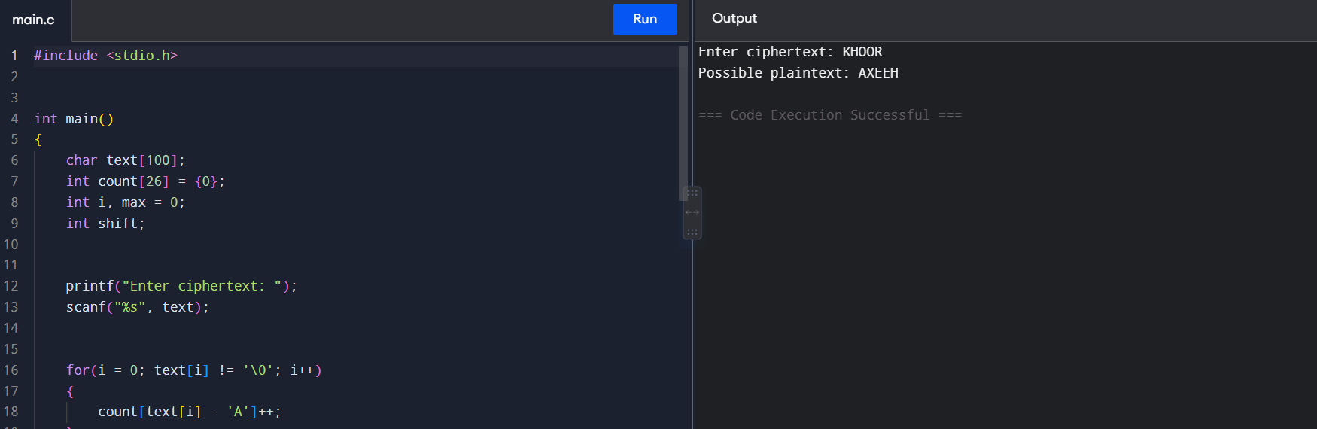

38. Hill Cipher
#include <stdio.h>

int main()
{
int k[2][2];
int p[2], c[2];

printf("Enter key matrix:\n");
scanf("%d %d", &k[0][0], &k[0][1]);
scanf("%d %d", &k[1][0], &k[1][1]);

printf("Enter two plaintext numbers: ");
scanf("%d %d", &p[0], &p[1]);

c[0] = (k[0][0] * p[0] + k[0][1] * p[1]) % 26;
c[1] = (k[1][0] * p[0] + k[1][1] * p[1]) % 26;

printf("Ciphertext: %c%c\n", c[0] + 'A', c[1] + 'A');

return 0;
}

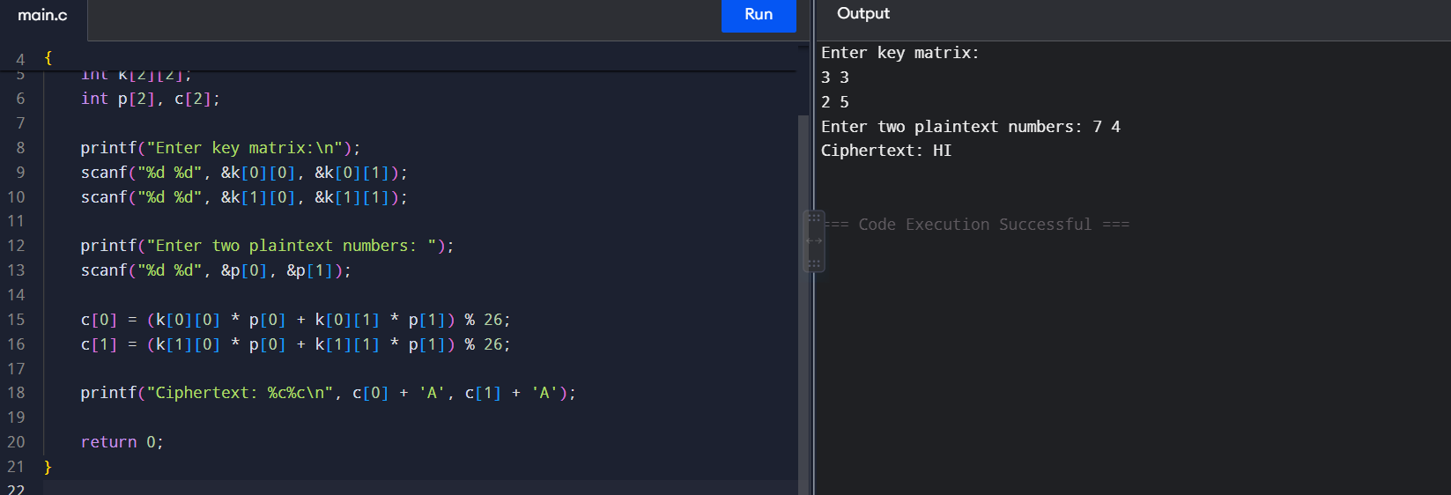

39. Frequency Attack on Additive Cipher#include <stdio.h>

int main()
{
char text[100];
int count[26] = {0};
int i, max = 0, shift;

printf("Enter ciphertext: ");
scanf("%s", text);

for(i = 0; text[i] != '\0'; i++)
{
count[text[i] - 'A']++;
}

for(i = 1; i < 26; i++)
{
if(count[i] > count[max])
max = i;
}

shift = max - 4;

if(shift < 0)
shift += 26;

printf("Shift = %d\n", shift);

printf("Plaintext: ");

for(i = 0; text[i] != '\0'; i++)
{
printf("%c",
(text[i] - 'A' - shift + 26) % 26 + 'A');
}

return 0;
}
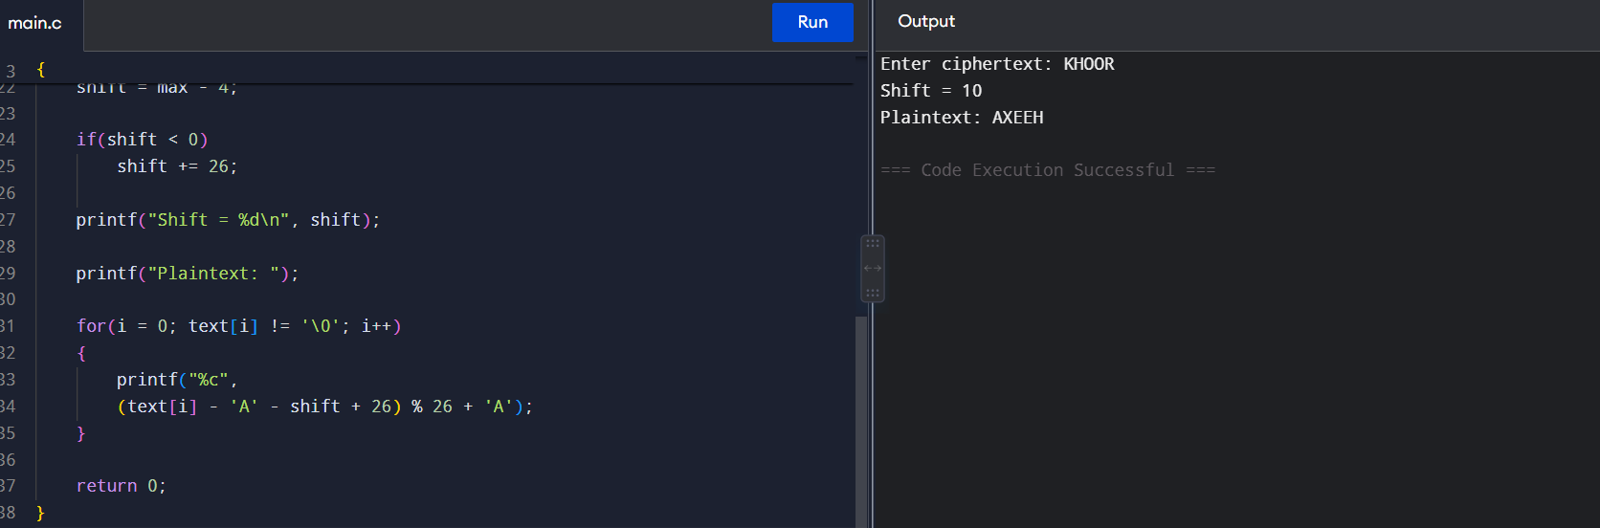

40.
#include <stdio.h>
int main()
{
char s[100];
int c[26] = {0}, i, max = 0, shift;
printf("Enter ciphertext: ");
scanf("%s", s);
for(i = 0; s[i]; i++)
c[s[i] - 'A']++;
for(i = 1; i < 26; i++)
if(c[i] > c[max])
max = i;
shift = (max - 4 + 26) % 26;
printf("Plaintext: ");
for(i = 0; s[i]; i++)
printf("%c", (s[i] - 'A' - shift + 26) % 26 + 'A');
return 0;
}
